ModelMuse with Support for PEST – Beta 8

# Summary

* ModelMuse can be used to visualize the effects of PEST parameter estimation on boundary conditions
* ModelMuse now supports prediction analysis and Pareto modes.
* There are a few PEST capabilities that will not be supported by ModelMuse. These are listed and the reasons for not supporting them are explained.

# Visualizing Boundary Conditions after Parameter Estimation

ModelMuse beta 7 allowed you to use parameter estimation with boundary conditions. However, it didn’t allow the user to visualize the effects of parameter estimation on the boundary conditions. This version of ModelMuse now allows you to see the effects of parameter estimation on boundary conditions.

See ModelMuse Beta 6 for a description of how to visualize array data modified by PEST.

For parameters that are not associated with a pilot point, ModelMuse can import parameter values from the .pval file. You can do this in the “Model|Manage Parameters” dialog box.

## MODFLOW-2005 and MODFLOW-NWT

To visualize the boundary conditions for MODFLOW-2005 and MODFLOW-NWT, start a new instance of ModelMuse and import the final version of the model generated by PEST. You can then visualize any part of the model using the normal methods built into ModelMuse.

## MODFLOW 6

ModelMuse does not currently have a method for importing a full MODFLOW 6 model into ModelMuse. Instead, select “File|Import|Import Model Feature from PEST.” Then select the input file and stress period that you want to visualize. The transient data for that stress period will be imported as new data sets into ModelMuse under “Model Results|ModelFeatures.” This does not modify the boundary conditions defined in ModelMuse so exporting the data again will not result in ModelMuse exporting the calibrated model. It should go without saying that the boundary condition file you import should correspond to the one defined in ModelMuse. You can not import a file for a model with a different grid than the one defined in ModelMuse.

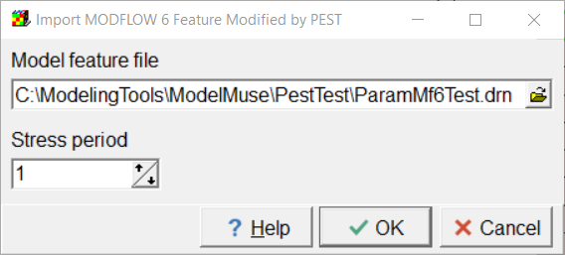

## SUTRA

ModelMuse does not currently have a method for importing SUTRA models into ModelMuse. Instead, select “File|Import|Import Model Features from PEST.” Then select the types of boundary conditions to import and either the main SUTRA input file or the SUTRA.FIL file for the current model. If SUTRA.FIL is selected, also select the time step that you want to visualize. If you select SUTRA.FIL, the transient data for that time step will be imported as new data sets into ModelMuse under “Model Results|ModelFeatures.” If you select the main SUTRA input file, just the data for the initial time step will be imported. This does not modify the boundary conditions defined in ModelMuse so exporting the data again will not result in ModelMuse exporting the calibrated model. It should go without saying that the file you select should correspond to the one defined in ModelMuse. You can not import a file for a model with a different mesh than the one defined in ModelMuse.

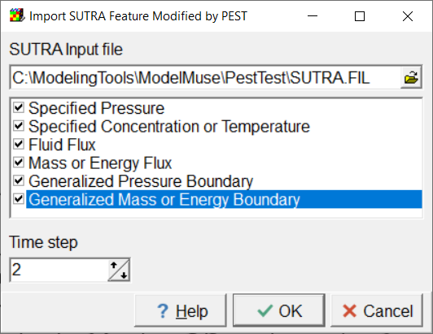

# Prediction Analysis and Pareto Modes

ModelMuse now supports the Prediction Analysis and Pareto modes in PEST. The user specifies the input for those models in new panes in the “Model|Pest Properties “ dialog box. If the Prediction Analysis mode is selected, ModelMuse will automatically create a new observation group named “predict” if it does not already exist. As explained in the PEST documentation, this observation group is required and must contain exactly one observation. The user is required to define such an observation.

The Prediction Analysis and Pareto modes require that the model first be run in Estimation mode. When this is done, one of the PEST output files will have the extension “.par” and will contain the parameter values estimated by PEST. After ModelMuse creates the PEST control file for the Prediction Analysis and Pareto modes, it use the PEST utility program PARREP to substitute the final parameter values from the parameter estimation process into the PEST control file and will run PEST or PESTCHEK with the modified control file.

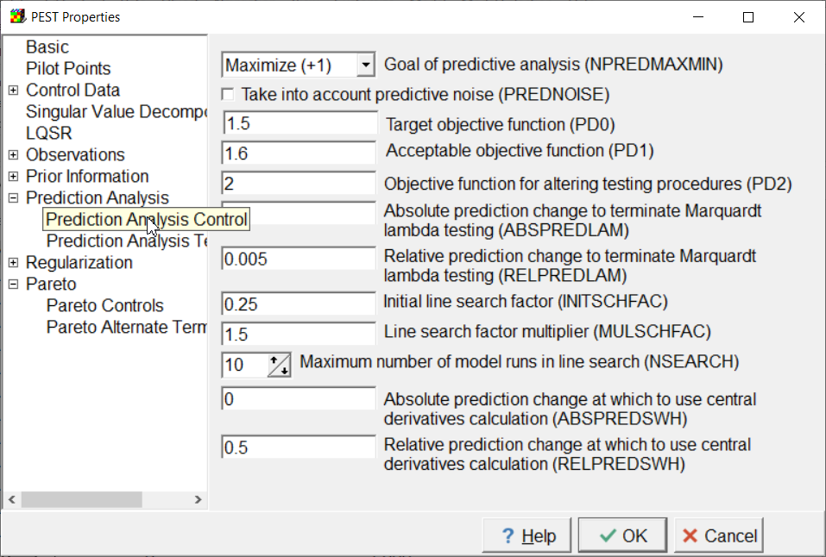

# Unsupported PEST Capabilities

* The Sensitivity Reuse section of the PEST control file will not be supported by ModelMuse. In chapter 7 of the PEST manual where the Sensitivity Reuse section is explained it says “Keep in mind also, that PEST’s SVD-assist functionality achieves a similar outcome, but in a more sophisticated fashion. Hence activation of PEST’s sensitivity reuse functionality is not, in general, advisory.” Because PEST’s SVD-assist functionality is supported, supporting sensitivity reuse seems superfluous.
* Automatic User Intervention will not be supported by ModelMuse. In chapter 6.3 of the PEST documentation it states “Before describing PEST’s automatic user intervention functionality in detail, it should be pointed out that truncated singular value decomposition as a solution process for an ill-posed inverse problem plays a similar role to that of automatic user intervention; however it is far more effective and far more efficient than automatic user intervention in stabilizing the solution process of that problem.” Because PEST’s truncated singular value decomposition is supported by ModelMuse, supporting automatic user intervention seems superfluous.
* The Derivatives Command Line Section is not supported by ModelMuse because the models supported by PEST do not have the capability of writing any elements of the Jacobian matrix.